NIKIA YUNG – FULL BIO

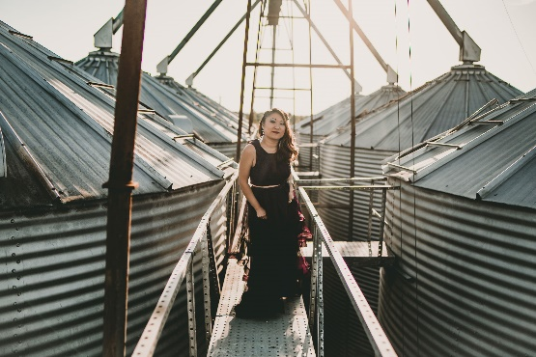
Nikia Yung grew up in a small farm town, Finksburg, MD. Surrounded by music at an early age, Yung followed in the footsteps of her mother, a locally-renowned piano instructor with a soulful voice and gospel songwriting chops. Yung was immersed in music by the age of seven, studying piano and violin, competing in competitions, performing in recitals and orchestras.
After attending the Peabody Preparatory throughout high school and beginning her bachelors in Music Performance at the Peabody Institute of Music, Yung broke ties with her home state and traveled to the University of Delaware to finish her degree. It was there in the practice rooms between masterclasses and rehearsals that Yung fell in love with the art of songwriting.
Following college, Yung moved back to Baltimore, MD and performed the circuit with Mason Vixon, a local country-rock band favorite for nearly four years opening for American Idol Contestants, acting as pre-show entertainment for Kenny Chesney and Tim McGraw, and various harbor festivals.
In 2014 Yung released her first solo album, "Taller Than Trees", a 10-track record with some of Yung's earliest creations as a songwriter and made her way to Nashville, TN. While in the great Music City, Yung kept busy performing regularly with Joanna Barbera, a published singer-songwriter, Hip-Hop sensation, Stealing Oceans, and various other artists and bands. Clocking many hours in the studio cutting violin on other tracks and projects, Yung became a quick dial for artists needing lush strings or beautiful melodic solo lines.
Now based out of Lafayette, LA, Yung has settled into a new city with a handful of new tricks. Determined to break the mold and perception of violin, Yung is pushing the limits and writing new material featuring violin in an unconventional way. Learning how to use both, violin and voice, she is transforming genre and creating a new sound.
"Wild Beasts", a 6-song EP is due to drop early 2019. Featuring songs with a bigger punch and a sea of strings, this EP will be vastly different than Yung's earlier writing. Hold on to your knickers, folks...

